Hello and welcome to Snowball

Below are easy use to instructions on how to use Snowball and how to upload a place and to leave a review.

Step 1

Download Snowball from to your Apple or Android device.
You will find it under ‘Snowball Community’. Links for both are below.

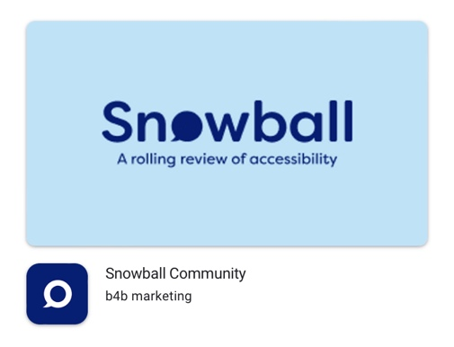
Apple

https://apps.apple.com/gb/app/snowball-community/id1624679548

Android

https://play.google.com/store/apps/details?id=uk.bespoke4business.snowball&hl=en_GB&gl=US

Step 2

Sign up and register to Snowball, please note you will get an email confirmation, if you do not receive one, please check your spam folder.

Hints and tips

When sighing up do not use your own name as your user name otherwise it will appear on Snowball. Choose your own username.

Once your signed up your ready to go.

How to upload a place or venue:

Snowball is user generated. This means that Snowball grows and grows as users add more places and reviews.

First search for the place you want to see in the box ‘Where are you going?’ please make sure you use the name of the place and town, village or city is well for example ‘McDonald’s, Loughborough’. If McDonalds Loughborough has not been added then you will be prompted to add this to Snowball via the blue ‘Add new place’ button then just follow the simple on-screen instructions.

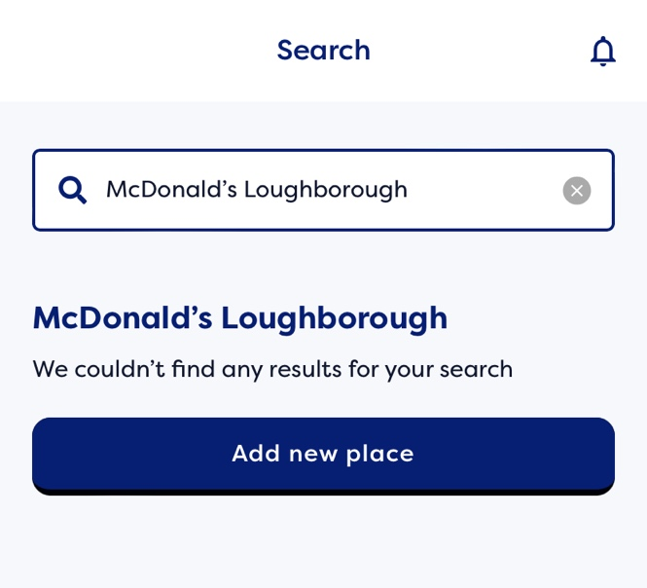

Hints and tips

It is quicker to have a photo of the place or venue before starting a review.

How to add a review?

Adding a review could not be easier.

Search the place you want to review, if it is already on Snowball, it will populate and then just click ‘Write a review’ and follow-on screen instructions.

If the place needs adding just add the place following the instructions above and once the place or venue has been added it will ask you to leave a review.

If you have any difficulties or issues using Snowball, please do not hesitate to contact us at Support@snowball.community.

